**WOMEN IN SOCIETY** -Sakshi Nigam, BVCOE



The society today is an amalgam of a myriad of traditional and modern lifestyles. Women, in both the spheres have been striving to acquire the same position as men since eternity. The resolute and determined have successfully ameliorated their terribly ramshackled and crumbled lives by assiduous efforts in order to annihilate the tradition of a patriarchal society. Albeit the incongruent environment prevented them from excelling, the persistent women were now determined to achieve acme of excellence and equality.

These perpetual efforts are resulting into some women rising to the forefront of the human society. On the other hand, the less fortunate continue to struggle to beat the once sought invincible bug arduously as their fight still remains in its infancy. Men, the influential ones, seem intent on enjoying their liberty and often turn Nelson’s eye on the issue of equality of women.

The most disturbing question is-why are women considered as the weaker sex? Women have their presence felt in every walk of life, be it domestic or a non-domestic front. They have succeeded in contributing significantly in fields like military, defence, financial and banking sector, science and technology among many others.

Women all around are fired with instructions on how their conduct should be at every phase of their lives. Amidst the many voices that bark these orders there lacks a sense of assurance. The other side of the coin portrays an entirely different scenario. Men everywhere have the freedom to choose and guard their decisions. Why? Women, like men, must have the liberty to take stand on every aspect of their lives and should not suffer from the consequences of this ultimate act of dominance.

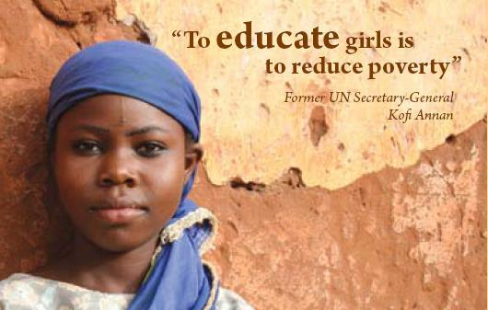Women shouldn’t sell themselves short as they must realise they’re worth their weight in gold. As rightly quoted by Eleanor Roosevelt, “A women is like a tea bag- you can’t tell how strong she is until you put her in hot water”. The ability of women shouldn’t be questioned and this evil act of discrimination should be put to a stop.